City of Dallas Historic Planning Commission
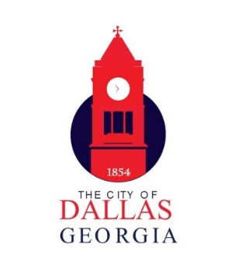
2022 MEETING SCHEDULE

Certificate of Appropriateness Deadline

Last Filing Date | Publication Date | Meeting Date
January 17th, 2022 | January 27th ,2022 | February 15th, 2022
February 14th, 2022 | February 24th,2022 | March 15th,2022
March 14th,2022 | April 28th,2022 | April 19th,2022
April 18th,2022 | April 1st, 2021 | May 17th,2022
May 16th,2022 | May 26th,2022 | June 21st,2022
June 20th,2022 | June 30th, 2022 | July 19th,2022
July 18th,2022 | July 28th,2022 | August 16th,2022
August 15th,2022 | August 25th,2022 | September 20th,2022
September 19th,2022 | September 29th,2022 | October 18th,2022
October 17th,2022 | October 27th,2022 | November 15th,2022
November 14th,2022 | November 24th,2022 | December 20th,2022
December 19th,2022 | December 29th,2022 | January 17th, 2023
January 16th ,2023 | January 26th,2023 | February 21st,2023

Completed COA application must be submitted by 5pm on the filing date.

City of Dallas | 129 East Memorial Drive | Dallas, Georgia 30132 | 770.443.8110

