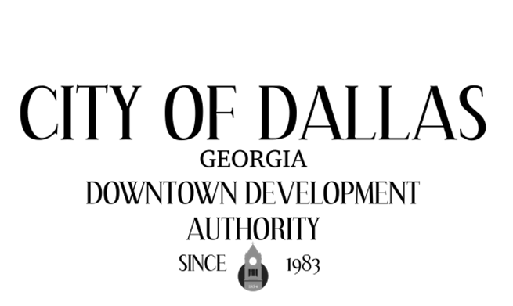

July 7th, 2026
City Hall Council Chambers
129 E. Memorial Dr
Dallas GA 30132

CALL TO ORDER

INVOCATION AND PLEDGE

VISITORS

APPROVAL OF MINUTES
06/02/2026, 06/10/2026-Special Called

EXECUTIVE SESSION

NEW BUSINESS
- IGA City/DDA

ADJOURNMENT:

NEXT MEETING:
August 4th, 2026

