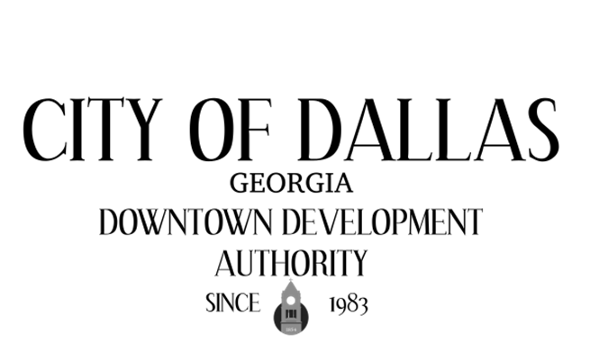

May 5th, 2026 4:00pm
City Hall Council Chambers
129 E. Memorial Dr
Dallas GA 30132

CALL TO ORDER

INVOCATION AND PLEDGE

VISITORS

APPROVAL OF MINUTES
04/07/2026

EXECUTIVE SESSION

NEW BUSINESS
- Consultant Review

ADJOURNMENT:

NEXT MEETING:
June 2nd, 2026

