 | 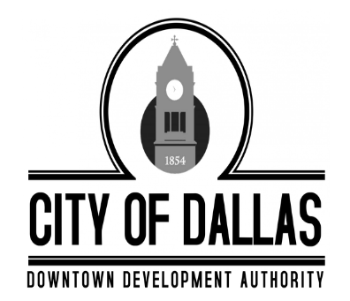 |  | City of Dallas  Downtown Development Authority
 |  |  | Tuesday, April 7th, 2026
 |  |  | 4:00 PM
 |  |  | City Hall, 129 E. Memorial Drive, Dallas GA 30132
Individuals with disabilities who require certain accommodations in order to allow them to observe and/or participate in this meeting, or who have questions regarding the accessibility of a meeting or the facilities, are required to promptly contact the City’s ADA Coordinator Brandon Rakestraw at 770.443.8110 ext. 1401 to allow the city to make reasonable accommodations for those persons.
 |  | MINUTES

CALL TO ORDER -Called to order at 4:11pm

PRESENT
Mike Cason
Susan Haynes
James Kelly
Sammy Callahan
Jody Harwell

ABSENT
Jolee Kitchen

STAFF
Cheyenne Cook
Darrin Keaton- Legal

INVOCATION AND PLEDGE
Darrin Keaton lead the invocation and pledge

RECOGNITION OF VISITORS AND COMMENTS
No Visitors

MINUTES APPROVAL
- Motion to adopt the March 3rd, 2026 Regular Meeting Minutes

Motion made by Board Member Susan Haynes to approve the meeting minutes with correction, Seconded by Board Member Jody Harwell. All in favor (1 absence, 1 vacancy)

EXECUTIVE SESSION
Motion was made by Board Member Sammy Callahan to enter into executive session, Board Member Mike Cason seconded, all in favor. (1 absence, 1 vacancy) Executive Session began at 4:28pm

Motion was made by Board Member Susan Haynes to end executive session, Board Member Jody Harwell seconded, all in favor. (1 absence, 1 vacancy) Regular session resumed at 4:50pm

OLD BUSINESS
None

NEW BUSINESS
- Discussion in regards to the new city hall.
- Board Member Sammy Callahan made a motion to approve resolution DDA-2026-04 authorizing the acquisition of 100 W Griffin St. Board Member Susan Haynes seconded; all in favor. (1 absence, 1 vacancy)

ADJOURNMENT
Board Member Mike Cason made a motion to adjourn the meeting at 5:25pm, Board Member Jody Harwell seconded. All in favor. (1 absences, 1 vacancy) Meeting Adjourned.

