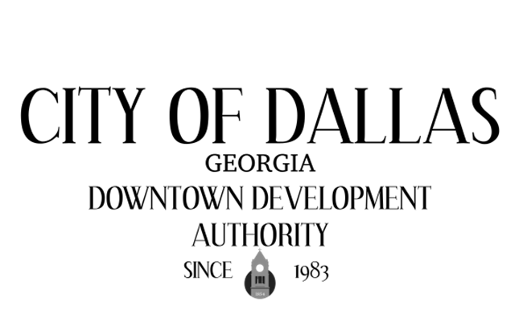

March 3rd, 2026 4:00pm
City Hall Council Chambers
129 E. Memorial Dr
Dallas GA 30132

CALL TO ORDER

INVOCATION AND PLEDGE

VISITORS

APPROVAL OF MINUTES
02/03/2026

EXECUTIVE SESSION

NEW BUSINESS
- Boost Grant Application 02-2026- 109 W. Spring Street

ADJOURNMENT:

NEXT MEETING:
April 7th, 2026

