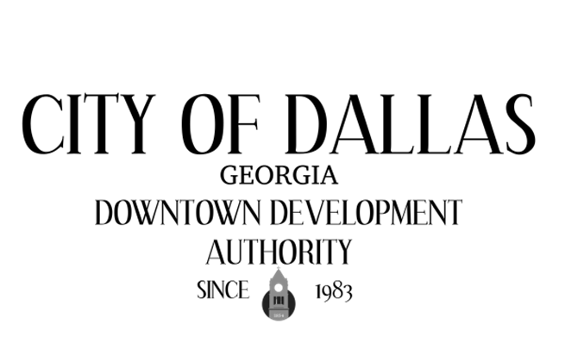

February 3rd , 2026 4:00pm
City Hall Council Chambers
129 E. Memorial Dr
Dallas GA 30132

CALL TO ORDER

INVOCATION AND PLEDGE

VISITORS

APPROVAL OF MINUTES
01-06-2026

EXECUTIVE SESSION

NEW BUSINESS
- Boost Grant Application- 221 Main Street

ADJOURNMENT:

NEXT MEETING:
March 3rd, 2026

