 | 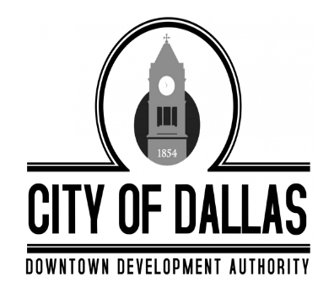 |  | City of Dallas  Downtown Development Authority
 |  |  | Tuesday, December 2nd, 2025
 |  |  | 4:00 PM
 |  |  | City Hall, 129 E. Memorial Drive, Dallas GA 30132
Individuals with disabilities who require certain accommodations in order to allow them to observe and/or participate in this meeting, or who have questions regarding the accessibility of a meeting or the facilities, are required to promptly contact the City’s ADA Coordinator Brandon Rakestraw at 770.443.8110 ext. 1401 to allow the city to make reasonable accommodations for those persons.
 |  | MINUTES

CALL TO ORDER -Called to order at 4:02pm

PRESENT
Mike Cason
Susan Haynes
James Kelly
Sammy Callahan

ABSENT
Jody Harwell
Jolee Kitchen

STAFF
Amber Whisner
Darrin Keaton- Legal

INVOCATION AND PLEDGE
James Kelly lead the invocation and pledge

RECOGNITION OF VISITORS AND COMMENTS
No Visitors

MINUTES APPROVAL
- Motion to adopt the November 11th, 2025 Regular Meeting Minutes

Motion made by Board Member Susan Haynes with correction to spelling error, Seconded by Board Member Mike Cason. All in favor (2 absences, 1 vacancy)

EXECUTIVE SESSION
Motion was made by Board Member Mike Cason to enter Executive Session to discuss real estate at 4:04pm, Seconded by Board Member Susan Haynes. All in favor (2 absences, 1 vacancy)

Motion was made by Board Member Mike Cason to close Executive Session and reopen the regular meeting at 4:21pm, Seconded by Board Member Sammy Callahan. All in favor (2 absences, 1 vacancy)

OLD BUSINESS
None

NEW BUSINESS
- Coming out of Executive Session, Board Member Sammy Callahan made a motion to allow Chairman Kelly to negotiate and sign agreement pertaining to Land Swap 1. Board Member Susan Haynes seconded. All in favor (2 absences, 1 vacancy)
- Motion was made to approve Boost Grant Application for 318 Main Street in the amount of $876.46.
Motion was made but Board Member Susan Haynes, Seconded by Board Member Sammy Callahan. All in favor (2 absences, 1 vacancy)
ADJOURNMENT
Board Member Susan Haynes made a motion to adjourn the meeting at 4:35pm, Board Member Sammy Callahan seconded. All in favor. (2 absences, 1 vacancy) Meeting Adjourned.

