 | 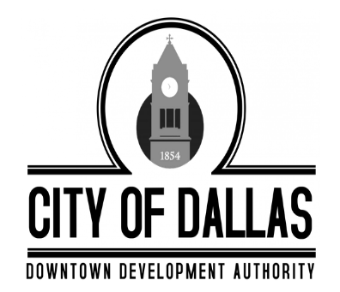 |  | City of Dallas  Downtown Development Authority
 |  |  | Tuesday, January 6th, 2026
 |  |  | 4:00 PM
 |  |  | City Hall, 129 E. Memorial Drive, Dallas GA 30132
Individuals with disabilities who require certain accommodations in order to allow them to observe and/or participate in this meeting, or who have questions regarding the accessibility of a meeting or the facilities, are required to promptly contact the City’s ADA Coordinator Brandon Rakestraw at 770.443.8110 ext. 1401 to allow the city to make reasonable accommodations for those persons.
 |  | MINUTES

CALL TO ORDER -Called to order at 4:06pm

PRESENT
Mike Cason
Susan Haynes
James Kelly
Sammy Callahan
Jody Harwell

ABSENT
Jolee Kitchen

STAFF
Amber Whisner
Darrin Keaton- Legal

INVOCATION AND PLEDGE
Board Member Sammy Callahan lead the invocation and pledge

RECOGNITION OF VISITORS AND COMMENTS
No Visitors

MINUTES APPROVAL
- Motion to adopt the December 2nd, 2025 Regular Meeting Minutes

Motion made by Board Member Susan Haynes, Seconded by Board Member Sammy Callahan. All in favor (1 absence, 1 vacancy)

EXECUTIVE SESSION
No Executive Session was needed.

OLD BUSINESS
None

NEW BUSINESS
- Nominees were received for 2026 Officers. The following were the nominees in each position. No position had opposition.
Chair- James Kelly
Vice-Chair- Sammy Callahan
Treasurer- Mike Cason
Secretary- Amber Whisner
Board Member Sammy Callahan made motion to accept officer nominations as presented and appoint James Kellly as Chair, Sammy Callahan as Vice Chair, Mike Cason as Treasurer, and Amber Whisner as Secretary. Board Member Jody Harwell seconded. All in favor. (1 absence, 1 vacancy)
- Discussion was made in regards to the New City Hall construction progress.
ADJOURNMENT
Board Member Sammy Callahan made a motion to adjourn the meeting at 4:58pm, Board Member Mike Cason seconded. All in favor. (1 absences, 1 vacancy) Meeting Adjourned.

