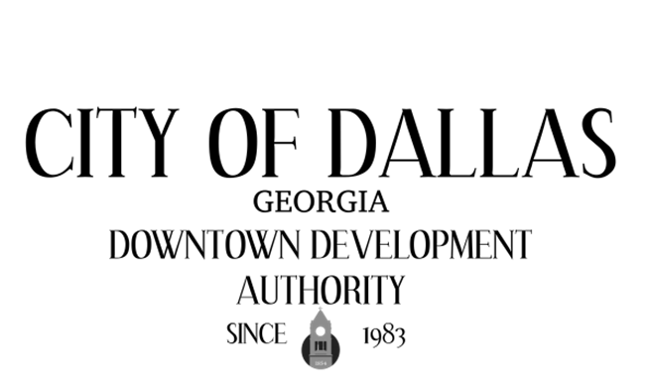

January 6th, 2025 4:00pm
City Hall Council Chambers
129 E. Memorial Dr
Dallas GA 30132

CALL TO ORDER

INVOCATION AND PLEDGE

VISITORS

APPROVAL OF MINUTES
12/02/2025- Regular

EXECUTIVE SESSION

NEW BUSINESS
- Election of Officers

ADJOURNMENT:

NEXT MEETING:
February 3rd, 2026

