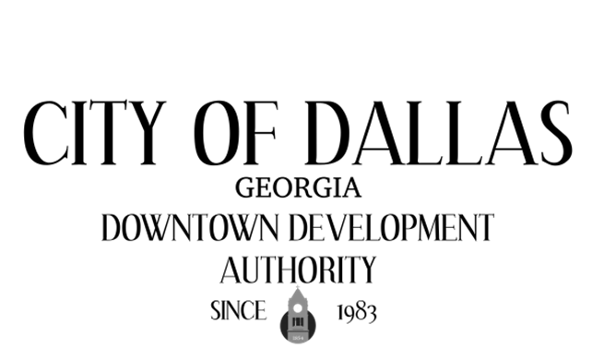

Minutes
August 5th, 2025 4:00pm
City Hall Council Chambers
129 E. Memorial Dr
Dallas GA 30132

No Quorum- Agenda tabled to next meeting.

CALL TO ORDER

INVOCATION AND PLEDGE

VISITORS

APPROVAL OF MINUTES
05/06/2025- Regular
06/25/2025- Special Called
07/08/2025- Regular

EXECUTIVE SESSION

NEW BUSINESS
- Director’s Report

ADJOURNMENT:

NEXT MEETING:
September 9th, 2025

